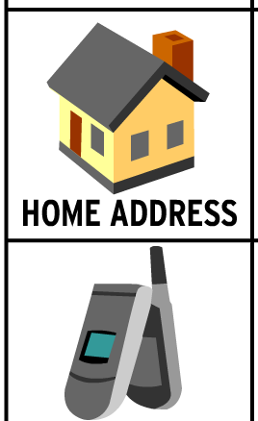
Name:

Date: ... . .Y .?!'·.?.9.4..................

TECHNOLOGY > DIGITAL CITIZENSHIP > INFORMATION PRIVACY

CONSEQUENCE CHART

Describe what can happen if scammers obtain each of the following types of information.

NAME

PHONE NUMBER
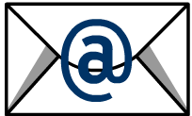

EMAIL ADDRESS
,._.,_.... n_
!:.. sc:=:::J

BANK ACCOUNT NUMBER
CREDIT CARD NUMBER
1999-2014 BrainPOP. All rights reserved. Visit us at http://www.b rainpop.com

